Electrical impedance and measurement
The under-pinning theory for through-vial impedance spectroscopy

Geoff Smith
School of Pharmacy, De Montfort University, Leicester, United Kingdom

Contents
Electrical impedance and measurement 1
1.1 Voltage and current 3
1.1.1 Resistors 6
1.1.2 Capacitors 7
1.2 Impedance 16
1.3 Resistance vs conductance and impedance vs admittance 19
1.4 Capacitive reactance (The electrical impedance of a capacitor) 20
1.5 Electrical impedance of substances 22
1.6 The measurement of impedance 24
1.7 Fundamental electrical circuit components 25
1.8 Combinations of impedance elements and equivalent circuits 26
1.9 Interfacial impedance of electrodes 28
1.10 Capacitance relaxation from Interfacial polarization 29
1.11 Dielectric relaxation of dipole reorientation in water 35
1.12 Dielectric relaxation of proton transfer in ice 35
1.13 Anomalous dielectric dispersion in the unfrozen fraction 36
1.14 References 37

Voltage and current
The electrical potential of a charge (symbol, $Q$) placed in an electrical field (symbol, $E$) is defined as the potential energy per unit charge, and represents the potential for the charges to do work, whereas the voltage (symbol, $V$) is the difference in electrical potential between two points in the electrical field (Figure 1).
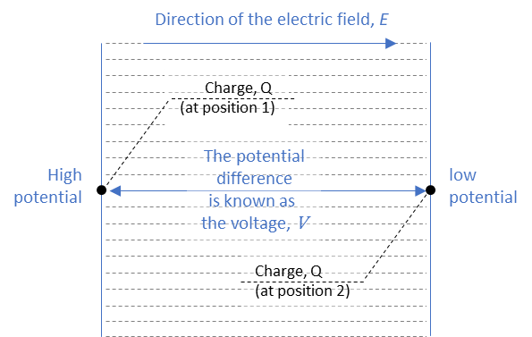
Figure 1 Schematic of an electric field, with dashed lines showing the field lines
The voltage provides the net electromotive force (emf) which causes charges (i.e., electrons) to move through a circuit. The flow of charge is known as a current (symbol, $I$) and is defined as the rate at which charge flows passed a fixed point in the circuit as a result of a difference in electrical potential (Figure 2).
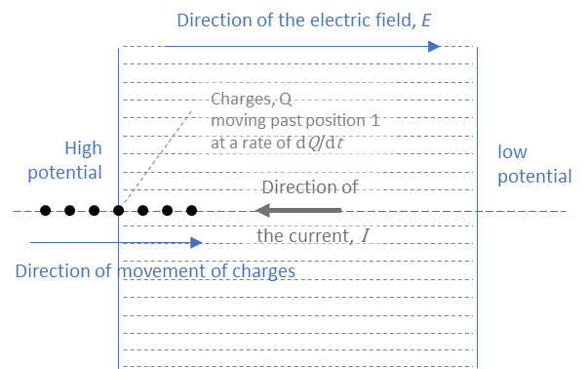
Figure 2

The rate of charge flowing past the defined point, is expressed by the differential equation
$$I={dQ}/{dt}$$ | Eq. 1
where $dt$ is a finite period of time in seconds and $dQ$ is the amount of charge in coulombs, with 1 coulomb being equal to 1/(1.602176634×10⁻¹⁹) elementary charges. Rounded to 5 significant figures, the number of elementary charges in 1 coulomb is 6.2415×10¹⁸ and one ampere of current represents one coulomb of electrical charge moving past a point in the circuit in a period of one second.
For the current to flow through an electrical circuit there has to be a closed loop pathway from the point of high potential to the point of low potential. Without a closed loop there is no circuit to speak of and no current will flow, even if there is a voltage.
In the schematic of circuit diagrams, the voltage is represented by either that depicting the plates on battery or circle which is marked variously with a positive and negative charge for a dc voltage and a sinusoidal waveform for an ac voltage.
Table 1 summary of the essential characteristics of voltage and current
 | Voltage | Current
Symbol (unit) | $V$ | $$I$$
Standard unit | volt, V | ampere, A
SI unit | 1 V = 1 joule per coulomb (J C⁻¹) | 1 A = 1 coulomb per second (C s⁻¹)
Definition | An electrical potential difference between two points in an electrical field | The rate of flow of charge between two points in an electrical field as a result of the difference in electrical potential
Field created | Electrostatic  The higher the voltage between two points the greater the field  The further apart the two potentials, that create the voltage, the weaker the field | Magnetic  The stronger the current the stronger the field
Measurement instrument | Voltmeter | Ammeter
Notation | Upper case italic for the symbols: voltage and current  Upper case plain for the units: volt, ampere, joule, coulomb and second

Resistors
For a resistor, the response current $I$ may be proportional to the stimulating voltage provided the applied voltage is not too high. If the condition of proportionality exists over a range of voltages, it means that these observations are being recorded for linear response region of the resistor. The other point to make is that this proportionality between current ($I$) and voltage ($V$) is exactly a statement of Ohm’s law ($V=IR$) in which the constant of proportionality is the electrical resistance ($R$). A potential difference of 1 V applied to a resistance of 1 ohm would result in 1 ampere of current, i.e., 6.2415×10¹⁸ electrons (elementary charges) passing through the resistor in one second.
In effect, Ohm’s law is stating that an increase in the voltage results in a proportional (linear) increase in current, with the resistance being defined as $R=V/I$ (Figure 3). The gradient of the line is 1 milliamp per volt which is the same as $1×{10}^{-3}$amps per volts. Given that resistance of the element is determined from the applied voltage (in volts) divided by the resultant current (in amps) then the resistance may be read off the graph from the inverse of the gradient, provided the gradient is quoted in amps per volt. This gives a resistance of 1000 Ω or 1 k Ω.
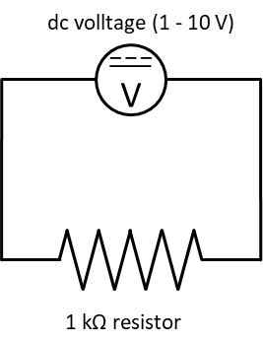 | 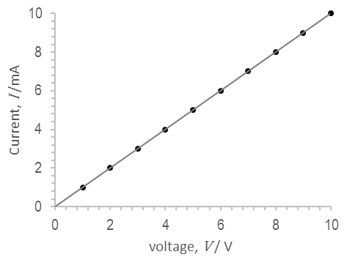
Figure 3 LEFT: Electrical circuit with a dc voltage (from 1 to 10 V) being applied to a resistor of value 1000 ohm (1 kΩ); RIGHT: plot of the current that results from the application of a series of voltages from 1 to 10 V, in increments of 1 V. Note that the current is plotted as milliamperes (mA).
The resistance of an electrical circuit effectively controls the rate of flow of charge to any of the other components in the circuit, as we shall see when we next look at how capacitors behave when a voltage of applied.
Conductance ($G$) is the inverse of the resistance and is given by the ratio of the current to the voltage
$$G=1/R=I/V$$ | Eq. 2
The higher the current for any defined value of voltage, then the higher the conductance.

When two resistances are in series (i.e., connected end-to-end like the links in a chain) their individual values can be added together to give the total resistance.
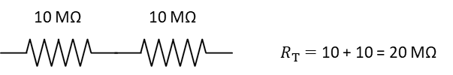

Capacitors
For a capacitor, the response to the application of a static (dc) voltage is more complex than for a resistor, in that the current depends not only on the magnitude of the voltage but also the time from the point of the application. To understand this, take a circuit element of a parallel plate capacitor to which a static voltage is applied via some power supply, e.g., a battery (Figure 4). The positive side of the applied potential difference pulls electrons from the plate connected to the positive side of the power supply resulting in a positively charged plate. These electrons travel around the circuit and are pushed onto the plate connected to the negative side of the power supply, resulting in a negatively charged plate. The build-up of charge on the negative plate results in a repulsive force that slows down the rate of accumulation of electrons until the potential of the plate is, in effect, the same as the potential of the power supply; Effectively, at this point the charging process can be considered to be complete.
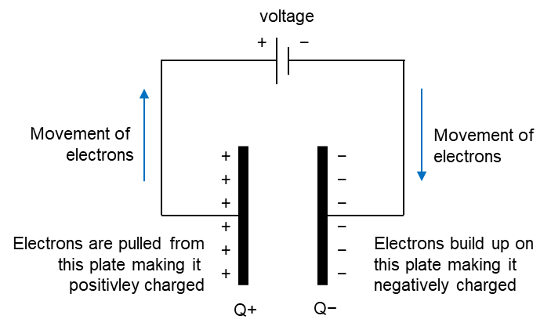
Figure 4 Schematic of a ciruit with a capacitor attached to a voltage source (power supply) via a pair of wires. Inside the power supply is known as the internal circuit and everything attached to the terminals of the volateg source, i.e. the wires and the capacitor are known as the external circuit.
The total amount of charge that builds up on the plates ($Q_{max}$) is proportional to the magnitude of the applied voltage ($V_{o}$),
$$Q_{max}=C.V_{o}$$ | Eq. 3
with the constant of proportionality ($C$) being the electrical capacitance, or simply the capacitance of the plates (measured in farads, F). Note that while electrons flow around the external circuit and give rise to a current, there is no charge passing through the capacitor. This situation is very different to that for the electrical resistance of an object, where the charge carriers pass through it.
The above description of the charging of the capacitor over-looks the practical aspect of how the voltage is applied to the capacitor via the electrical circuit, in that it ignores the fact that the cables (wires) and connectors connecting the capacitor to the voltage supply will inevitably have a finite resistance that controls the current flow to the capacitor. It follows that the charge that flows from the source to the capacitor are impeded to some degree and so cannot reach the plates of the capacitor in an instant. This resistance effectively controls the rate at which capacitors charge, and results in the gradual accumulation of charge that is depicted in Figure 5.
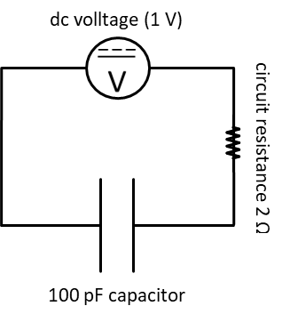 | 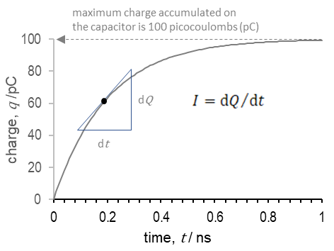
Figure 5 Example charging profile for a 100 pF capacitor in an electrical circuit with a 2 Ω resitor with a voltage source of 1 V
In order to fully understand this charging process, we need to recognise how the voltage applied to the circuit is partitioned between the resistor and the capacitor.
In the configuration of this circuit the two elements are in a series combination, i.e., one after the other; as opposed to being in parallel, i.e., side by side. In a series combination, the same current value flows through all the elements, whereas in a parallel combination the same voltage is applied across each element (see Figure 6).
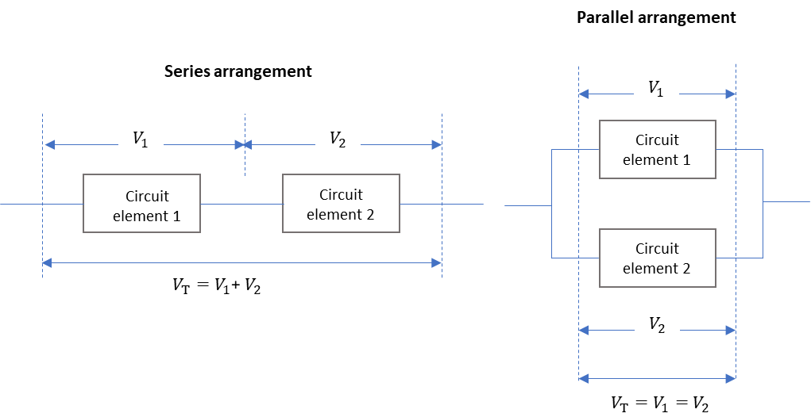
Figure 6 Relationships between the total voltage applied to a combination of circuit elements in series and in parallel, to the individual voltages across each element
Kirchhoff’s current law states that the current $i_{S}\left(t\right)$ through the series circuit is the same across each of the elements, i.e.,
$$i_{S}\left(t\right)=i_{R}\left(t\right)=i_{C}\left(t\right)$$ | Eq. 4
It is not necessary to differentiate as to whether one is addressing the current through one component or the other, as they are the same, and hence it is sufficient to write $i_{S}\left(t\right)$ or simply $i\left(t\right)$ for the current.
Whereas, Kirchhoff’s voltage law which states that the sum of the voltage drops across each component of the circuit must equal zero. In other words, the voltage of the supply is balanced by the sum of the voltage across the resistor $V_{R}\left(t\right)$ and the voltage across the capacitor $V_{C}\left(t\right)$, the statement of which is written in a mathematical notation as
$$V_{o}-V_{R}\left(t\right)-V_{C}\left(t\right)=0$$ | Eq. 5
$$V_{o}=V_{R}\left(t\right)+V_{C}\left(t\right)$$
The voltage across the resistor will follow Ohm’s law, hence
$$V_{R}\left(t\right)=i\left(t\right).R$$ | Eq. 6
where $i\left(t\right)$ is the current flowing at time $t$. Therefore Eq. 5 may be rewritten as
$$V_{o}=i\left(t\right).R+V_{C}\left(t\right)$$ | Eq. 7

Transient analysis of the current through an RC Circuit
At the instant that the voltage is applied to the circuit (i.e., time $t$ = 0) there has been no time for the charges to flow around the circuit to reach the plates of the capacitor and so there will be no charge on the capacitor. It follows, that both $Q_{c}\left(t=0\right)$ and $V_{c}\left(t=0\right)$ are both zero and the capacitor behaves almost like a short circuit, with only the resistor to offer a small impediment to the flow of charge. At time zero, the entire source voltage is dropped across the resistor and the current is therefore at a maximum of
$$i\left(t=0\right)={V_{o}}/R$$ | Eq. 8
Next, we need to develop our understanding of how the voltage develops across the capacitor as a function of time. In other words, to develop a transient analysis of the response of the RC circuit to the input from an applied voltage. The target here is to derive an expression for the voltage across the capacitor as a function of time.
At any point in time the charge on the capacitor $Q(t)$ is related to the voltage $V_{C}(t)$ which is dropped across the capacitor via the expression
$$Q(t)=C.V_{c}(t)$$ | Eq. 9
Taking the derivative of Eq. 9 with respect to time gives
$$\frac{dQ}{dt}=C.\frac{dV_{c}}{dt}$$ | Eq. 10
Given that the rate of change of the charge accumulation on the capacitor ${dQ}/{dt}$ is effectively the transient current $i(t$) that flows through the entire circuit then Eq. 10 may be rewritten as.
$$i(t)=C.\frac{dV_{c}}{dt}$$ | Eq. 11
Substituting the expression for the transient current (Eq. 11) into Eq. 7 then gives a differential equation for the circuit in terms the voltage across the resistor $RC.{dV_{c}}/{dt}$ and the static voltage of the source $V_{o}$ and the time variant voltage across the capacitor $V_{c}\left(t\right)$
$$V_{o}=RC.\frac{dV_{c}}{dt}+V_{c}\left(t\right)$$ | Eq. 12
Eq. 12 is then rearranged in two steps, i.e.,
$$V_{o}{- V}_{c}\left(t\right)=RC.\frac{dV_{c}}{dt}$$ | Eq. 13
and
$$\frac{dt}{RC}=\frac{dV_{c}}{\left[V_{o}{-V}_{c}\left(t\right)\right]}$$ | Eq. 14
in order to separate the variables of time on one side of the equation and voltage on the other.
The next step is to integrate each side of Eq. 14. The left side is integrated with respect to $t$ to give
$$\int{\frac{1}{RC}dt}= \frac{t}{RC}$$ | Eq. 15
and the right side is integrated with respect to $V_{c}$
$$\int{\frac{1}{\left[V_{o}{-V}_{c}\left(t\right)\right]}dV_{c}}= -ln\left[V_{o}{-V}_{c}\left(t\right)\right]+K$$ | Eq. 16
to give the expression
$$\frac{t}{RC}= -\ln\left(V_{o}{-V}_{c}\left(t\right)\right)+K$$ | Eq. 17
where $K$ is a constant.
Since, the voltage across the capacitor $V_{C}\left(t\right)$ is zero at $t=0$, then by substitution into Eq. 17 we get an expression for the constant, $K$
$$K= \ln{V_{o}}$$ | Eq. 18
Hence Eq. 17 becomes
$$\frac{t}{RC}= \ln{V_{o}}-\ln\left(V_{o}{-V}_{c}\left(t\right)\right)$$ | Eq. 19
Which rearranges to
$$\frac{t}{RC}= \ln{\frac{V_{o}}{V_{o}{-V}_{c}\left(t\right)}}$$ | Eq. 20
or
$$-\frac{t}{RC}= \ln{\frac{V_{o}{-V}_{c}\left(t\right)}{V_{o}}}$$ | Eq. 21
Taking the exponent of both sides, gives
$$e^{{-t}/{RC}}= \frac{V_{o}{-V}_{c}\left(t\right)}{V_{o}}$$ | Eq. 22
$$V_{o}e^{{-t}/{RC}}= V_{o}{-V}_{c}\left(t\right)$$ | Eq. 23
Which is then rearranged to give an expression for the voltage across the capacitor
$$V_{c}\left(t\right)= V_{o}{-V}_{o}e^{{-t}/{RC}}$$ | Eq. 24
$$V_{c}\left(t\right)= V_{o}(1-e^{{-t}/{RC}})$$ | Eq. 25
Eq. 25 is an example of an exponential function of the form that results in a time profile for the voltage that develops on the capacitor (Figure 7). As time tends towards infinity then the curve gets closer and closer to the asymptote, which is the horizontal line with a value equal to the magnitude of the supply voltage, $V_{o}$ (i.e., 1 V in the specific case being discussed here). Another way to think of the asymptote of a curve is a line is that it represents the tangent to the curve at a point at infinity.
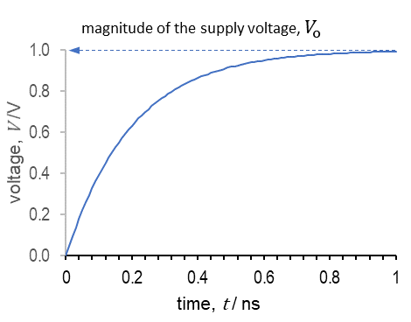
Figure 7 Profile of the voltage that develops on a capacitor as a function of time. The curve converges on the voltage ($V_{o}$) that is provided by the power supply
It is clear from the time profile in Figure 7 that a voltage which is applied in an instant (i.e., a step voltage) only ‘appears’ on the plates of the capacitor as time elapses. The characteristic time for the accumulation of voltage (and hence charge) on the plates of a capacitor is known as the time constant (symbol, $τ$) and is given by the product of the magnitude of the capacitor ($C$) and the magnitude of the resistor ($R$),
$$τ=RC$$ | Eq. 26
where the values for the resistance ($R$) and capacitance ($C$) are in ohms (Ω) and farads (F), respectively.
When the elapsed time, $t$ equals one time constant, $RC$, then
$$V_{c}\left(t=RC\right)=V_{o}\left(1-e^{-1}\right)= V_{o}\left(1-0.37\right)=0.632V_{o}$$ | Eq. 27
The value $0.632V_{o}$ means that the capacitor charges to ~63% of the applied voltage after one period.
After further time periods have elapsed the percentage of charge increases from 86.47% at 2 time periods to 99.99% at 9 time periods. To all intents and purposes, the capacitor is considered to be fully charged after 5 time-constants when the percentage charge reaches 99.3%. However, the reality is that the capacitor never charges to 100% of the applied voltage but gets very close to it.
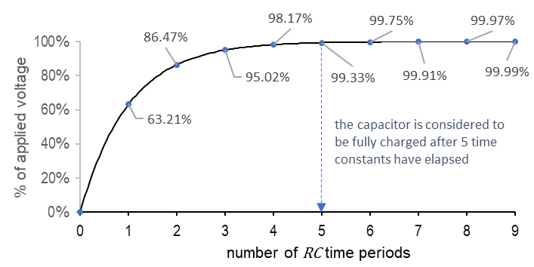
Figure 8
Charge accumulation profile
The voltage (${ V}_{c}\left(t\right)$) on the capacitor at time $t$ is related to the charge accumulated at ($Q\left(t\right)$) at time $t$, via the capacitance of the plates, $C$ (see Eq. 3)
$$V_{c}\left(t\right)= \frac{Q\left(t\right)}{C}$$ | Eq. 28
and hence Eq. 25 may be re-written as
$$\frac{Q\left(t\right)}{C}=\frac{Q_{max}}{C}(1-e^{-t/{RC}})$$ | Eq. 29
where $Q_{max}$ is the maximum charge that can be stored by the capacitor, $t$ is the time in seconds; Which then reduces to
$$Q\left(t\right)=Q_{max}(1-e^{-t/{RC}})$$ | Eq. 30
Charging current
Returning to Eq. 7, the voltage across source is equal to the combined voltages across the resistor and the voltage across the capacitor, i.e.,
$$V_{o}=i\left(t\right).R+V_{C}\left(t\right)$$
Substituting in Eq. 25 (which is the expression for the voltage across the capacitor, $V_{C}\left(t\right)$)
$$V_{o}=i\left(t\right).R+V_{o}(1-e^{{-t}/{RC}})$$
And rearranging so that the voltage terms are on one side of the equation and the current on the other, gives
$$i\left(t\right).R= V_{o}- V_{o}(1-e^{{-t}/{RC}})$$
$$i\left(t\right).R= V_{o}- V_{o}-{V_{o}e}^{{-t}/{RC}}$$
Which reduces to
$$i\left(t\right).R= -V_{o}e^{{-t}/{RC}}$$
And therefore
$$i\left(t\right)= -\frac{V_{o}}{R}e^{{-t}/{RC}}$$
At time zero the term $e^{{-t}/{RC}}$ equals $-1$, and so the current is at its maximum value of $i\left(t\right)= {V_{o}}/R$ (refer back to Eq. 8. Thereafter the current experiences an exponential decay with a time constant equal to RC (Figure 9).
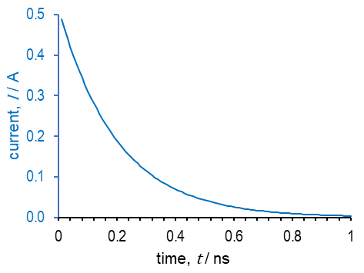
Figure 9 Current variation with time during the charging of a capacitor
Discharge of a capacitor
For completeness, let us briefly consider the discharging of a capacitor. When the capacitor discharges, it does so at the same rate (i.e., with the same time constant) as the charging process, but does so according to the following function.
$$V_{c}\left(t\right)=V_{o}e^{-t/RC}$$ | Eq. 31
After a time period equal to the time constant the voltage on the capacitor will have dropped to
$$V_{c}\left(t\right)=V_{o}e^{-1}$$ | Eq. 32
Which is the same as $V_{o}{/e}^{1}$. In other words, the time constant represents the time for the voltage on the capacitor to fall to 1/e of its original value. 1/e equals ~0.32 and so at $τ=RC$ the voltage has dropped to ~32% of its original value.

Impedance
The impedance of an object refers to its “resistance” to current flow on the application of a stimulating voltage, which is oscillating in some periodic wave form. It is usual for the wave form to be sinusoidal, with an oscillation frequency of $ω$ (radians per second, rad s⁻¹) and amplitude of $V_{o}$ (in volts, V). The mathematical expression for a sinusoidal wave form of a voltage as a function of time, at a single angular frequency of $ω$, is given by
$$V\left(ω, t\right)=V_{o}\sin{ωt}$$ | Eq. 33
where $ωt$ is an angle, in radians.
Note that frequency is also defined in cycles per second, i.e., hertz (Hz) for which the symbol $f$ is used. Given that one cycle is in effect one revolution of the voltage vector around a circle, i.e., $2π$ radians (360°) then the conversion between the cyclic frequency and angular frequency, is to divide the angular frequency by $2π$
$$f=ω/2π$$ | Eq. 34
The example waveform in Figure 10 has been generated for an ac source voltage with amplitude $V_{o}$ = 10 V and an oscillation frequency of 1 kHz. The corresponding period for a single oscillation of the voltage phasor is 0.001 s (i.e., 1 microsecond, ms).
On the right is a diagram of a rotating arrow, known as a phasor. The length of the phasor corresponds to the maximum voltage ($V_{o}$) which is achieved once it has rotated in the anti-clockwise direction through an angle of 90°. As the phasor continues to rotate through to 270 °, the voltage reaches a minimum, or one could say reaches another maximum, but in the opposite direction to its previous maximum value. The opposite direction of the voltage phasor is accounted for on the chart by the negative values for the voltage over the second half of the oscillation cycle.
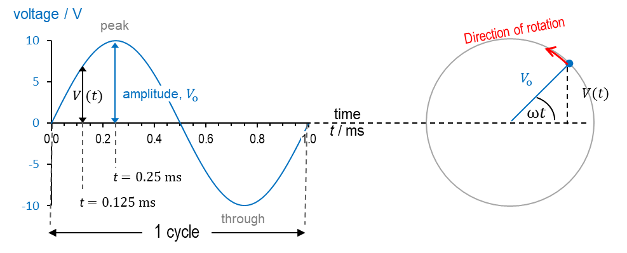
Oscillation frequency of 1 kHz, where one cycle is completed in a period of 1 millisecond
Figure 10 Sinusoidal voltage with angular frequency $ω$ and cyclic frequency $f=ω/2π$
The symbols $ω, t$, in brackets after the symbol for voltage $V\left(ω, t\right)$in Eq. 33 means that the voltage is dependent on both the angular frequency of the rotating phasor and the time. To explain this by example, first look at the waveforms in Figure 11 to see how the voltage varies with time, at one of two fixed frequencies of 1 kHz and 2 kHz. At time $t$, the voltage has reached a maximum value of $V_{o}$ for the 1 kHz waveform then at a later time, the voltage has decreased to a fraction of the maximum voltage; By comparing two waveforms at two different frequencies you can see how the voltage is different at any fixed value of time.
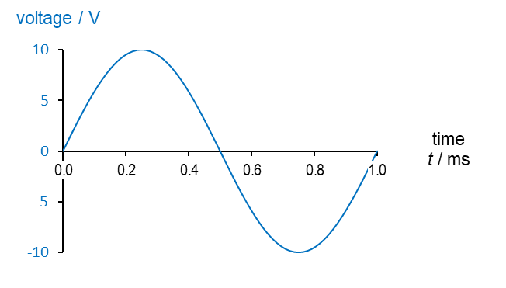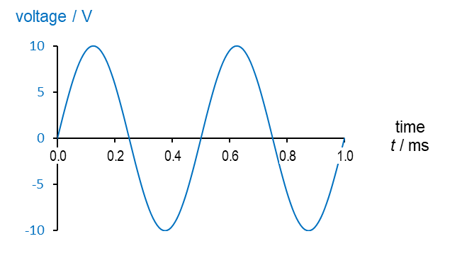
Oscillation frequency of 1 kHz
Oscillation frequency of 2 kHz
Figure 11

Resistance vs conductance and impedance vs admittance
It follows from Ohm’s law, that when an oscillating voltage is applied to a resistor, the resultant current is also oscillating, and that these oscillations occur at the same time and frequency as the voltage. In other words, as the voltage increases and then decreases then so does the current, with the corresponding points of each waveform reaching their maximum or minimum displacement at the same time. This phenomenon is referred to as the voltage and current being in phase.
Figure 12 gives an example voltage waveform with amplitude 10 V and a cyclic oscillation frequency of 1 kHz (i.e., 1000 cycles per second) which is applied to a 10 MΩ resistor and results in an oscillating current phasor of magnitude 1 µA (microampere).
$$I=V/{R=10/\left(10×{10}^{6}\right)}=1×{10}^{-6} A$$
On the right side of Figure 12 is the phasor diagram for the voltage and current, which again demonstrates the attribute of being in phase with one another.
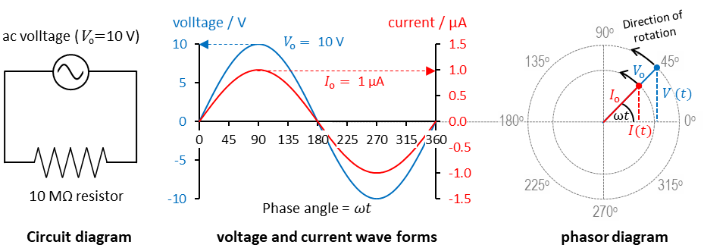
Figure 12
Again, as per Ohm’s law, the impedance $Z(jω)$ of the resistor is the constant of proportionality between the applied oscillating voltage vector ($V\left(ωt\right)$) and the resultant oscillating current ($I(ωt)$) but here, in both cases, the voltage and the resultant current are oscillating.
$$V\left(ωt\right)=Z\left(jω\right)×I(ωt)$$ | Eq. 35
Rearranging Eq. 35 then gives an expression for the impedance
$$Z\left(jω\right)={V\left(jωt\right)}/{I\left(jωt\right)}$$ | Eq. 36
Note the inclusion of the complex operator $j$ alongside $ω$, in the brackets after the symbols for the impedance. This is to indicate that the impedance may be a complex quantity, in which case the normal rules of multiplication/division (addition/subtraction) will not apply. This is certainly the case when we consider the case of a capacitor, whereby the oscillations of the current are out of step with the oscillating voltage. In such cases, the mathematical operations of manipulating complex numbers will be required.
The analogous term for conductance is the admittance $Y\left(jω\right)$
$$Y\left(jω\right)={I\left(jωt\right)}/{V\left(jωt\right)}$$ | Eq. 37
Resistance and impedance, and conductance and admittance, are known as transfer functions, in that they define the relationship between an input, e.g., a voltage, and the output, i.e., the current ( (Macdonald and Barsoukov, 2018) p. 107). In its general format the transfer function can be written as
$$G\left(ω\right)={X_{out}\left(jω\right)}/{X_{in}\left(jω\right)}$$ | Eq. 38

The term immittance is also used as a collective term for both admittance and impedance formulae.

Capacitive reactance (The electrical impedance of a capacitor)
For a resistor, we have seen how the current that flows on application of either a step voltage or an oscillating voltage, exactly mirrors that of the applied voltage (see Figure 12). However, by combining Figure 7 and Figure 9 into one (Figure 13) we can see how the current that flows on the application of a step voltage to a capacitor is at a maximum when the voltage on the capacitor is zero and conversely, the current tends to zero when the voltage on the capacitor reaches a maximum (equal to that of the supply voltage).
Figure 13 comparison of the voltage that develops on a capacitor and the current that flows
So, what are the implications for this phenomenon when the voltage applied to the capacitor is oscillating in the shape of the sinusoidal waveform described in Figure 10. Take the example of a capacitor of 20 pF, across which is applied an oscillating source voltage of frequency 1 kHz and peak amplitude of 10 V (Figure 14). A number of observations can be made:
- The current has a maximum amplitude of 1.26 μA but is shifted along the time axes, such that the peak current occurs at time 0 s as opposed to time 0.25 s which is the point when the voltage peaks.
- Given that the current peaks before the voltage (i.e., 0 s is less than 0.25 s) then we say that the current phasor is ahead of the voltage.
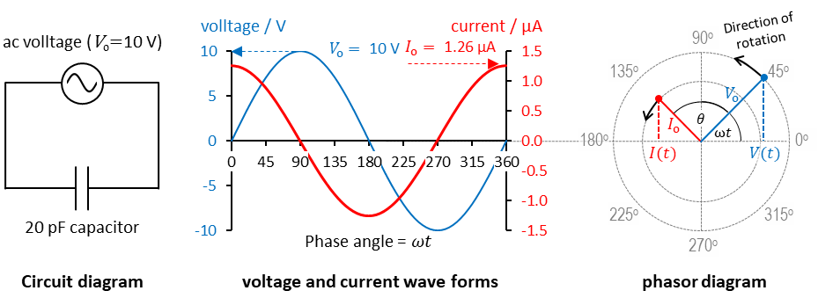
Figure 14 Phasor diagram of the current resulting from the application of an oscillating voltage of amplitude 10 V to a capacitor of 20 F
Now consider the response function (i.e., the current); the expression for which is analogous to that of the voltage (see Eq. 33).
$$I\left(ω,t\right)=I_{o}sin⁡(ωt+θ)$$ | Eq. 39
but has the addition of $θ$ to the rotating angle of the voltage $ωt$, to account for the difference between the angle of the current vector and the angle of the voltage vector, at any moment in time. In other words, $θ$ describes the phase difference between the two phasors.
Here, $I_{o}$ is the amplitude of the current wave form, whereas the symbol $V_{o}$ gave the amplitude of the voltage wave form. The negative sign in the case of Eqn 3 means that the current is lagging behind the voltage.
Switching to polar coordinates, the alternating voltage and current signals (Eq. 40 and Eq. 41) are written, respectively as
$$V \left(ω, t\right)= V_{o}e(jωt)$$ | Eq. 40
and
$$I \left(ω, t\right)= I_{o}e(jωt+θ)$$ | Eq. 41
where $j$ denotes the imaginary operator (i.e., the square route of −1).
With these notations, Eq. 36 can be re-written as
$$Z\left(ω\right)=\frac{V(ω)}{I(ω)}=\frac{V_{o}}{I_{o}}e^{jθ}=\left|Z(ω)\right|e^{jθ}$$ | Eq. 42
where $\left|Z(ω)\right|$ denotes the impedance magnitude. The above equation is further modified by using Euler’s relationship ($e^{jθ}=cosθ+jsinθ$) to separate the impedance into a real part, $Z^{'}\left(ω\right)$, and an imaginary part, $jZ^{''}(ω)$:
$$Z\left(ω\right)=\left|Z\left(ω\right)\right|\left(\cos{θ}+j\sin{θ}\right)=Z'\left(ω\right)+jZ''(ω)$$ | Eq. 43

where $Z^{'}=\left|Z\left(ω\right)\right|\cos{θ}$ and $Z''=\left|Z\left(ω\right)\right|\sin{θ}$. Elsewhere, the symbols for real and imaginary impedance are written as $Re\left\{Z\right\}$ and $Im\left\{Z\right\}$.
From above equation, the magnitude and the phase of the impedance is derived from
$$\left|Z(ω)\right|=\sqrt{{Z^{'}}^{2}(ω)+{Z''}^{2}(ω)}$$ | Eq. 44
$$θ\left(ω\right)=\tan^{-1}\left(\frac{Z''(ω)}{Z'(ω)}\right)$$ | Eq. 45
The real and imaginary components are drawn at right angles to one another on what is known as an Argand diagram, which like the phasor diagrams for the sinusoidal voltage and current and provides a convenient way to visualise the relationships between the two components of complex impedance.

Electrical impedance of substances
Let us assume, at first, that we have a substance that is homogeneous on the macroscopic and microscopic scales, e.g., a single-phase aqueous solution containing some dissolved electrolyte (such as sodium chloride). We need to consider two aspects of the electrical impedance of this object, the first are the intrinsic electrical properties of the substance from which the object is made, and the second is the extrinsic properties, which is the size or more specifically the geometry of the object.
For relatively simple substances, such as the example of an aqueous solution, we only need to consider the intrinsic electrical properties of the conductivity ($σ$) and relative permittivity (or dielectric constant, $ε$) of the substance. Simple aqueous solutions of salts, buffers, proteins, to the more complex systems comprising biological cell suspensions generally don’t display any inductive properties, so can be effectively ignored.
- The conductivity of the object ($σ$) or conversely its resistivity ($ρ=1/σ$) is a function of the concentration, valency (i.e. charge) and mobility of charge carriers; In the case of an isotonic solution of 0.9% w/v sodium chloride, the solution conductivity will be largely dominated by the diffusion of sodium ions and chloride ions, with each carrying a single positive and negative charge, respectively, and possessing its own specific conductivity (i.e., the conductivity per unit amount of substance). For example, the molar conductivities of the sodium and the chloride ions, in aqueous solution at infinite dilution, are 50 and 70 S cm² mol⁻¹, respectively.
- The relative permittivity, or dielectric constant, is simply a factor by which the permittivity of the substance is greater than the permittivity of free space. Think of it as a constant of proportionality rather than some parameter that is constant per se. For example, water has a relative permittivity of ~ 80 at room temperature when measured at relatively low frequencies, i.e. below 10 MHz. In other words, at frequencies that are sufficiently low to allow for the various polarization processes within the substance to respond within one cycle of the oscillating field. In the case of water, the polarization of the substance is dominated by the alignment of the water dipole with the applied field, with a smaller contribution from the formation of induced dipoles associated with the distortion of the electron cloud relative to the nucleus. Both processes are fast and so one can assume that the relative permittivity of an aqueous solution of electrolyte does not change over the frequencies accessible to the current TVIS technology, i.e., 10 Hz to 1 MHz.
For the extrinsic properties it is often convenient to express the geometry of an object as a rectangular prism, which is commonly deployed in theoretical descriptions of electrical properties, to describe the geometry of an object placed in between two parallel plate electrodes, may be defined by its length ($d$) and cross-sectional area ($A$). In more practical applications, the electrodes are invariably shaped as discs, owing to the relative simplicity of incorporating a disc within a suitable spacer for the purpose of creating a sample cell (see Section ??).
The resistance ($R$) and capacitance ($C$) of the object is then estimated from two quite simple expressions, which combine the intrinsic properties of resistivity ($ρ$) or relative permittivity ($ε$) respectively, with the extrinsic properties of geometry, i.e., length ($d$) and cross-sectional area ($A$).
$$R=\frac{d}{σA} or R=ρ\frac{d}{A}$$ | Eq. 46
$$C={ε.ε}_{o}\frac{A}{d}$$ | Eq. 47
Notice, that the resistance increases with the length of the object but decreases with the area (Eq. 46) whereas its vice versa for the capacitance, which decreases with the length of the object but increases with the area (Eq. 47).
For reasons that will become clear (when we consider how impedance measurements are undertaken in practice) this ratio of $d/A$ or $A/d$, is called the cell constant. If we were undertaking measurements of the capacitive properties of the substance under test then we would define our cell constant in terms of $A/d$, whereas if we were more concerned with the resistive properties of the object and design measurement cell according then we would define our cell constant in terms of $d/A$.
The design of the measurement cell should favour the measurement of the target parameter. For example, if the aim is to measure the capacitance of the object then the cell would be designed with a large surface area relative to the distance between the electrodes, in order to increase the capacitance of the measurement system.
Take note that, throughout the above narrative and what follows, there is a clear difference between the term object and the term substance. The object is the physical system that is being measured whereas the substance is the material from which the homogeneous object is made. When the impedance of the object is being described, then the various circuit elements of capacitance and resistance will be used, whereas when the impedance of the substance is being described then the various intrinsic electrical properties, of resistivity/conductivity and permittivity, will be used.
In some sense, this might also be one way in which to differentiate between the use of the term impedance spectroscopy from dielectric spectroscopy. When applying interpretations of electrical properties, we could use lumped circuit elements to describe the object, in our concept of impedance spectroscopy, whereas we would account for the cell constant in the measurement and use relative permittivity (i.e., dielectric constant) and conductivity to describe the substance, in our concept of dielectric spectroscopy.

The measurement of impedance
All impedance measurements require an electrode system coupled to some form of measuring instrument, which can be either
- an impedance analyser, bridge or LCR meter (if only one or a few discrete excitation frequencies are available), or
- an impedance spectrometer, if multiple frequencies over a wide range of frequencies, are available.
The electrode system is usually based on a pair of electrodes which are placed close to, but usually in direct contact with the object under test. For the measurement of dielectric, as opposed to conductive properties, these electrodes are usually made from gold-plated metal plates whose area is large relative to the separation of the electrodes. The cell constant referred to in Eq. 47 is therefore in favour of capacitance measurements, as opposed to resistance measurements, in which distance between the electrodes is more advantageous than having a large area electrode. The gold plate ensures that any electrochemical processes are supressed, owing to the relatively inert characteristic of the material.
In terms of the electrode design, it’s also more convenient to use circular electrodes as opposed to rectangular as its easier to produce a cylindrical sample cell (e.g., using a lathe to shape the inner and outer diameter of the cell) in which the electrodes are embedded. The only remaining concerns are:
- how to ensure that the sample cell can hold a liquid,
- how to fill the space between the electrodes (without trapping air), and
- how to allow for any expansion or contraction of the substance, with change to density that results from altering the temperature and/or in state (e.g., from liquid water to ice).
A potential difference is created by biasing the electrodes with the oscillating voltage, and then recording the current that flows around the circuit as a result of the applied voltage (as described in the earlier Section ). Once the phasors of voltage and current are known then the impedance of object is determined from the relationships between the two phasors, i.e., where the ratio of rms voltage to rms current gives the impedance magnitude ($\left|Z\right|$), and the phase difference between the voltage and current gives the impedance phase angle ($θ$).

Fundamental electrical circuit components
The electrical characteristics of a number of simple substances which define its overall impedance can be divided into elements, each represented by the lumped circuit components of a resistor, capacitor, and inductor, etc (Table 2). For example, a metal wire will have a small resistance (hence electrical charge passes easily through the material) and possibly some inductance, if made from a ferromagnetic material; Whereas a simple non-polar liquid such as hexane will have a very high electrical resistance, hence does not allow for the passage of charge, but instead has a capacity to store electrical charge.
From a cursory glance at the equations that define each element, one can see that the majority include the frequency ($ω$) of the applied sinusoidal voltage, indicating that impedance is a frequency dependent parameter. The exception is the resistance (R). Also given in table are the equivalent expressions for the admittance of each object (which is essentially the inverse of each impedance).
Table 2 Fundamental electrical elements and related impedances and admittances
Elements | Symbols | Impedance | Admittance
Resistor | R | R | $$\frac{1}{R}$$
Capacitor | C | $$\frac{1}{jωC}$$ | $$jωC$$
Inductor | L | $$jωL$$ | $$\frac{1}{jωL}$$

Given the inverse dependence on frequency of the of the impedance a capacitor, then the impedance magnitude of this element displays a characteristic slope of −1 in the plot of log impedance magnitude vs. log frequency (see Figure 15 A). Contrast to that for the impedance of a resistor, which is independent of frequency (see Figure 15 B).
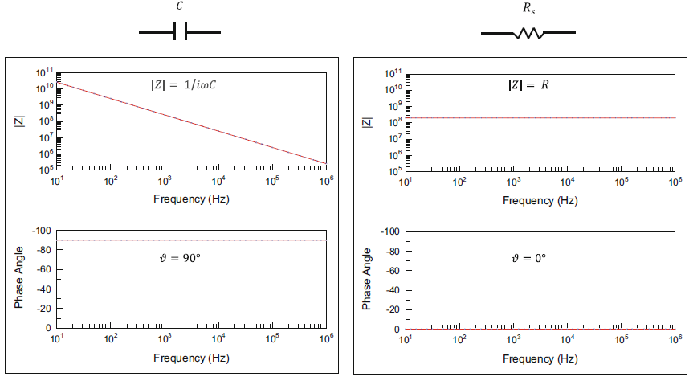
[B]
[A]
Figure 15 Impedance spectra for a capacitor (A) and a resistor (B) in terms of the impedance magnitude and phase angle.

Having identified these elements, the next stage is to build (assemble) them in an equivalent-circuits, in such a way that it reflects the physical attributes of the object. These equivalent circuits will be the subject of the next Section.

Combinations of impedance elements and equivalent circuits
In the previous example of the aqueous sodium chloride solution, it’s clear that the substance displays both resistive and capacitance behaviour and that these intrinsic properties may be determined by the measurement of the resistance and capacitance of a known geometry of the substance, e.g., a cuboid with two opposite surfaces, in contact with a pair of planar electrodes of area, $A$, that are separated by a distance $d$. The question is how to measure the capacitance and resistance from the electrical impedance.
The answer is to develop an appropriate model (i.e., equivalent circuit) which accurately embodies all attributes of the measurement system. For that, one needs to consider the physicality of the object in terms of the pathways for current to flow. We have seen from Section 1.1.2 that a basic level of understanding of how impedance elements combine, may be developed through the notion of elements being in series or in parallel with each other, and that this is a fundamental concept in equivalent circuit modelling, which considers the physical arrangement of the different elements.
At first, one might think that it would be sufficient to include only those elements that reflect the bulk characteristics of the object under test, i.e., the resistance and capacitance of the sodium chloride solution. We shall see later that this would be an over simplification of any practical measurement system, nevertheless it provides a good place to start. And so, if an object does possess resistive and capacitive behaviours (through which the electrical current may flow) then how might these characteristics be considered in terms of the collective impedance of the object. Here you may consider the two pathways to exist side by side, i.e., current can flow through the object along one route, via the conduction of ions, and at the same time along a separate route, via the charging (polarization) of the dipolar entities within the system. The model for that would be to place the resistance on one arm of a circuit and the capacitance on the other arm (Figure 16A). The real part of the current is then proportional to the resistance of the object and the imaginary part is proportional to the susceptance of the object, via the capacitance.
(A)  Equivalent circuit model for an object that has both capacitive (i.e., dielectric) and resistive behaviour | (B)  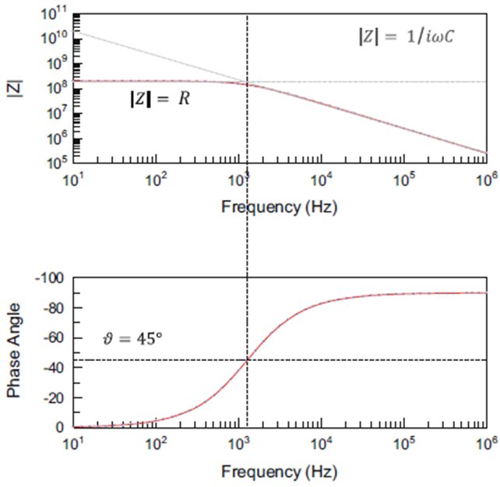
Figure 16 (A) Equivalent circuit model for a resistor and a capacitor in parallel; (B) the impedance of circuit in terms of the impedance magnitude ($\left|Z\right|$) and phase angle ($θ=0$°). The vertical dotted line demarks the transition from the dominance of the resistor at low frequencies (where $\left|Z\right|=R$ and $θ=0$°) and the dominance of the capacitor at high frequencies (where $\left|Z\right|=1/{iωC}$ and $θ=-90$°).
The only way to separate the real and imaginary impedances is to transform the equation so that there is a common denominator on both elements of the right side of the equation.

Interfacial impedance of electrodes
Until now we have considered the object simply in terms of its bulk electrical properties. Next, we will consider the process of undertaking an impedance measurement, by bringing an electrode in direct contact with the solution. Inevitably we have created an interface between the electrode and the substance. This interface will have its own impedance which combines in series with the impedance of the object we are trying to measure. Understanding what happens at the electrode(s) interface is therefore critical to our understanding of how to interpret the total measured impedance; in other words, to separate out that of the bulk properties of the object from that of the interface.
The first point to appreciate is that the charge carriers within the metal are electrons (which are negatively charged) whereas the charge carriers within the aqueous solution are ions, with both positive and negative charges.
In the case of a solid metal, the ionic charges in the solution cannot pass through the interface ‘into’ the metal. However, it is possible for electrons to exchange between the metal and the ions within the solution. If electrons from the metal were to exchange with ions in the solution, then that would be tantamount to an electrochemical reaction taking place, with the metal being either oxidised or reduced, and resulting in ions being created from the substance of the electrode or ions. The rate of exchange of electrons associated with these chemical reactions is in effect the current that flows through the interface, and as such can be defined by an electrical resistance known as a charge transfer resistance.
These reactions could irreversibly change the nature of the electrode and the solution; for example, the loss of metal from the surface would be considered as corrosion, whereas the addition of oxygen would result in oxidation. Such electro-active species are known as discharging species.
A branch of electrochemistry, known as electrochemical impedance spectroscopy (EIS) is used to measure model such reactions using a parallel combination of a resistor and a capacitor to model the interface, which is placed in series with a resistor to account for the ohmic conductance through the electrolyte.
However, for the measurement of bulk electrical properties, these electrochemical reactions are what should be avoided at all costs, and is why gold-plated metal electrodes are invariably used for the measurement of the bulk properties of aqueous solutions.
Nevertheless, at sufficiently high applied voltages, and/or low frequencies, or using a static DC voltage, there can be a reduction of a neutral species such as water, reacting with the electrode to create a gas such as oxygen or hydrogen, at the cathode and anode respectively. This is what happens when a minimum DC voltage of 2 V is applied to a platinum electrode placed in water (Grimnes and Martinsen,2015 p. 15, and Orazem and tribollet p. 89-90). At these voltages, the electrode passes current through its interface and thereby allows for a continual flow of current around the circuit. In other words, a DC current is permitted to flow.
Within the bulk solution, this current is carried by ions as was previously explained, with the sodium ions diffusing the to the anode (the negatively charged electrode) and the chloride ions diffusing to the cathode (the positively charged electrode).
The charge transfer resistance of the gold water interface is very high, which begs the question as to why any current flows through the substance due to ohmic conductance of ions.
In the liquid state, as in the case of the aqueous solution of sodium chloride, a metal electrode will polarise. In other words, it takes on a charge as electrons are exchanged with the liquid.

Capacitance relaxation from Interfacial polarization
In the case of a glass vial and its liquid contents (such as the above-mentioned solution of sodium chloride) a simple equivalent circuit model can be developed using a capacitor ($C_{g}$) for the glass wall, in series with a parallel combination of a resistor ($R_{s}$) and a capacitance ${(C}_{s}$) for the solution. A model such as this, which attempts to assign different elements to the various physical structures making up the object under test would be considered to be either the Model 1 (explanatory) type or the Model 2 (simplified explanatory) type that are described by Grimmes and Martinsen p. 329) in their reference to the bioimpedance of skin, for example. Model 1 attempts to assign lumped circuit elements to each and every component of the physical system whereas the Model 2 type focusses only on those components of the physical model that make the most significant contribution to the overall impedance. However, in some way the model proposed by (Smith and Polygalov,2019) is neither a Model 1 or a Model 2 type. The model is very much a simplification of the physical system, as it ignores the interfacial capacitance of the double layer at the glass solution interface, while making a simplification of the impedance of the glass by assuming it may be modelled by a simple capacitance when in fact glass displays some dispersive character that it more accurately modelled by a combination of CPE elements.
In order to build a mathematical model of the object, one needs to understand how to combine series and parallel circuit elements into one expression for the overall impedance: The total impedance of two circuit elements ($Z_{1}$ and $Z_{2}$) arranged in series is given by the rather straightforward addition of the two, individual impedances, i.e.,
$$Z_{T}=Z_{1}+Z_{2}$$ | Eq. 48
Here $Z_{1}$ might represent the impedance the glass vial and $Z_{2}$ represents the impedance the solution. From Table 2 we can see that $Z_{1}$ is given by
$$\frac{1}{{iωC}_{G}}$$ | Eq. 49
For the impedance of the solution ($Z_{2}$) we need to consider how to combine two circuit elements ($Z_{3}$ and $Z_{4}$) in parallel. In this case, the total impedance is given by the addition of the inverse of each individual impedance, i.e.,
$$\frac{1}{Z_{2}}=\frac{1}{Z_{3}}+\frac{1}{Z_{4}}$$ | Eq. 50
Which then rearranges to
$$Z_{T}=\frac{Z_{3}Z_{4}}{{Z_{3}+Z}_{4}}$$ | Eq. 51
Alternatively, for the parallel circuit it is more straightforward to first add the admittances of each object. So, in the case of the solution inside the vial, we may add the conductance of the resistor element (i.e., $1/{R_{s}}$) and the susceptance of the capacitor element (i.e., ${iωC}_{s}$), to give the overall admittance of the solution ($A_{s}$)
$$A_{s}=1/{R_{s}}+{iωC}_{s}$$ | Eq. 52
By taking the inverse of this expression we then arrive at the impedance of the solution inside the glass vial ($Z_{s}$), i.e.
$$Z_{s}=\frac{1}{\frac{1}{R_{s}}+{iωC}_{s}}$$ | Eq. 53
Combining Eq. 49 and Eq. 53 leads to the following expression for the overall impedance of the glass vial and its contents.
$$Z=\frac{1}{{iωC}_{G}}+\frac{1}{\frac{1}{R_{s}}+{iωC}_{s}}$$ | Eq. 54
This may be re-arranged to
$$Z=\frac{1}{{iωC}_{G}}+\frac{R}{1+{iωR}_{s}C_{s}}=\frac{1+iωR(C_{s}+C_{G})}{iωC_{G}-ω^{2}R_{S}C_{S}C_{G}}$$ | Eq. 55
Impedance may be more usefully represented by its equivalent in complex capacitance ($\hat{C}$), where,
$$\hat{C}=-\frac{1}{iωZ^{*}}$$ | Eq. 56
The reason being that relation phenomena clearly display as steps in the real part capacitance and a corresponding peak in the imaginary part capacitance.
Introducing the expression for the total impedance into the Eq. 56 then gives
$$\hat{C}=-\frac{1}{iω}\frac{iωC_{G}-ω^{2}R_{S}C_{S}C_{G}}{\left(1+iωR\left(C_{s}+C_{G}\right)\right)}$$ | Eq. 57
$$\hat{C}=-\frac{1}{iω}\frac{iωC_{G}-ω^{2}R_{S}C_{S}C_{G}}{\left(1+iωR\left(C_{s}+C_{G}\right)\right)}$$ | Eq. 58
Multiplying the top and bottom by $i$ then gives
$$\hat{C}=-\frac{i}{-1}\frac{iC_{G}-ωR_{S}C_{S}C_{G}}{\left(1+iωR(C_{s}+C_{G})\right)}$$ | Eq. 59
Which rearranges to
$$\hat{C}=\frac{i^{2}C_{G}-iωR_{S}C_{S}C_{G}}{\left(1+iωR(C_{s}+C_{G})\right)}$$ | Eq. 60
$$\hat{C}=\frac{-C_{G}-iωR_{S}C_{S}C_{G}}{\left(1+iωR(C_{s}+C_{G})\right)}$$ | Eq. 61
$$\hat{C}=-\frac{C_{G}+iωR_{S}C_{S}C_{G}}{\left(1+iωR(C_{s}+C_{G})\right)}$$ | Eq. 62
From this formula of the complex capacitance, expressions for real and imaginary capacitances can be written ($C^{'}$ and $C^{''}$, respectively) and in so doing explain some of the underlying features of the interfacial polarization peak.
The transformation starts with a multiplication of the nominator and denominator by the complex conjugate ($1-{iωR}_{S}(C_{S}+C_{G}$),
$$C^{*}=\frac{(C_{G}+iωR_{S}C_{S}C_{G})(1-{iωR}_{S}(C_{S}+C_{G}))}{(1+{iωR}_{S}(C_{S}+C_{G}))(1-{iωR}_{S}(C_{S}+C_{G}))}$$ | Eq. 63
Which rearranges to
$$=\frac{C_{G}+ω^{2}R_{S}^{2}C_{S}C_{G}(C_{S}+C_{G})-iωR_{s}C_{G}^{2}}{1-{(ωR_{S}(C_{S}+C_{G}))}^{2}}$$ | Eq. 64
Grouping the real and imaginary parts then gives expression for $C^{'}$ and $C^{''}$
$$C^{'}=\frac{C_{G}+ω^{2}R_{S}^{2}C_{S}C_{G}(C_{S}+C_{G})}{1+{(ωR_{s}(C_{S}+C_{G}))}^{2}}$$ | Eq. 65
$$C^{''}=-\frac{ωR_{S}C_{G}^{2}}{1+{(ωR_{S}(C_{S}{+C}_{G}))}^{2}}$$ | Eq. 66
Figure 17 shows model real and imaginary capacitance spectra that was generated from expressions Eq. 65 and Eq. 66, respectively.
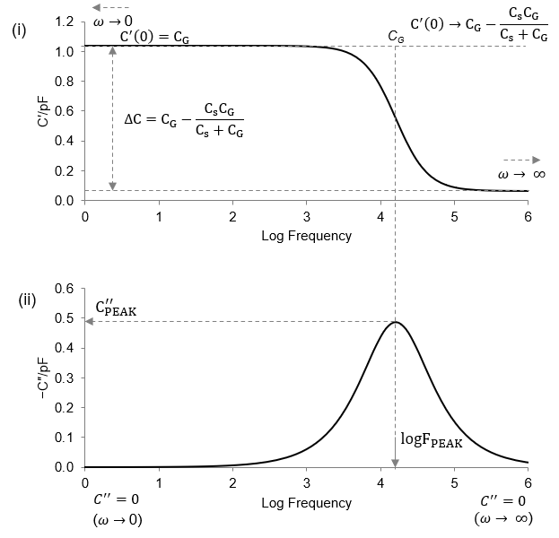
Figure 17
The arrows below the annotations $ω→0$ and $ω→∞$ are to indicate the direction in which the frequency tends towards zero and infinity, respectively. Frequencies at the lower and upper ends of the measured spectrum (i.e., 10 Hz and 1 MHz) might be considered an approximation for these two conditions, respectively. This is certainly true if the value of the real and or imaginary capacitance are close to (and ideally equal) to that predicted by either of these conditions.
For the real part spectrum, at frequencies where $ω→0$ then that part of the numerator of equation 31 which has a frequency term within it (i.e., $ω^{2}R_{S}^{2}C_{S}C_{G}(C_{S}+C_{G})$) tends to zero, and so to all intents and purposes $C^{'}\left(0\right)=C_{G}$.
At frequencies where $ω→∞$ the term $ω^{2}R_{S}^{2}C_{S}C_{G}(C_{S}+C_{G})$ dominate the numerator and the term ${(ωR_{s}(C_{S}+C_{G}))}^{2}$ dominates the denominator, so that the equation reduces to
$$C^{'}\left(∞\right)=\frac{ω^{2}R_{S}^{2}C_{S}C_{G}(C_{S}+C_{G})}{{(ωR_{s}(C_{S}+C_{G}))}^{2}}$$ | Eq. 67
The denominator ${(ωR_{s}(C_{S}+C_{G}))}^{2}$ is then rewritten as $ω^{2}R_{S}^{2}{(C_{S}+C_{G})}^{2}$ so that Eq. 67 becomes
$$C^{'}\left(∞\right)=\frac{ω^{2}R_{S}^{2}C_{S}C_{G}(C_{S}+C_{G})}{ω^{2}R_{S}^{2}{(C_{S}+C_{G})}^{2}}$$ | Eq. 68
Which then reduces to
$$C^{'}\left(∞\right)=\frac{C_{S}C_{G}}{C_{S}+C_{G}}$$ | Eq. 69
And so at high frequency to all intents and purposes $C^{'}\left(∞\right)={C_{S}C_{G}}/{\left(C_{S}+C_{G}\right)}$.
The change ${∆C}^{'}$ in the real part capacitance from low to high frequency is therefore
$${∆C}^{'}=C_{G}-\frac{C_{S}C_{G}}{C_{S}+C_{G}}$$
or
$${∆C}^{'}=\frac{{C_{G}}^{2}}{\left(C_{S}+C_{G}\right)}$$
For the imaginary part spectrum, at frequencies where $ω→0$ then the numerator of equation 32 (i.e., $ωR_{S}C_{G}^{2}$) also tends to zero, and so to all intents and purposes $C^{''}=0$. At frequencies where $ω→∞$ the denominator of equation 32 (i.e., $1+{(ωR_{S}(C_{S}{+C}_{G}))}^{2}$) reduces to ${(ωR_{S}(C_{S}{+C}_{G}))}^{2}$. We then have a numerator that is a function of $ω$ (i.e., $ωR_{S}C_{G}^{2}$) and a denominator that is a function of $ω^{2}$ (i.e., ${(ωR_{S}(C_{S}{+C}_{G}))}^{2}$) and so together the whole term tends towards zero, and so to all intents and purposes $C^{''}=0$, again.
As the frequency is increased, $C^{''}$ increases to a maximum, at which ${dC^{''}}/{dω}$ = 0
$$dC^{''}=-\frac{ωR_{S}C_{G}^{2}}{1+{(ωR_{S}(C_{S}{+C}_{G}))}^{2}} dω$$
Let
$$R_{S}C_{G}^{2}=A$$
$$R_{S}\left(C_{S}{+C}_{G}\right)=B$$
$$\frac{dC^{''}}{dω}=-\frac{Aω}{1+B^{2}ω^{2}}$$
$$C_{max}^{''}=\frac{C_{G}^{2}}{2(C_{S}+C_{G})}$$ | Eq. 70
at a frequency of Eq. 70
$$ω_{max}=\frac{1}{R(C_{S}+C_{G})}$$ | Eq. 71
and then decreases to 0 as the frequency $ω→∞.$
The value of the real part of capacitance at $ω→0 is C^{'}=C_{G}.$
and the value at $ω→∞$ is Eq. 71
$$C^{'}=\frac{C_{S}C_{G}}{(C_{S}+C_{G})}$$ | Eq. 72

Dielectric relaxation of dipole reorientation in water
So far, there has been an assumption that the relative permittivity of the substance is the same at each and every frequency of the measured spectrum. This, was stated earlier, is certainly the case for a dielectric liquid such as water over the relatively low frequencies of the TVIS measurement system. At higher frequencies, and into the microwave region of the electromagnetic spectrum (in the case of liquid water) the period of oscillation of the applied field becomes comparable to the response time of the polarization event.
Once the period for one oscillation of the applied field becomes comparable to the time required for the permanent dipoles of water to respond, then the rotation of the dipoles gets “out of sync” with the changing field and as a consequence contributes to the conductivity, rather than a contribution to the permittivity. For this reason, its more accurate to describe this phenomenon as dielectric loss (i.e., a reduction in permittivity) rather than an increase in conductivity per se. Nevertheless, given that it’s a phenomenon that occurs with an oscillating applied field, it may also be grouped with a general concept of ac conductivity.
As the frequency of the applied field increases further, there becomes insufficient time for dipoles to align within the applied field; and in that sense the dipoles might be said to be relaxing rather than polarising in the field. Which is why the term dielectric relaxation is used to denote the transition from the polarised state at low frequency to the non-polarised (relaxed) state at high frequencies. That is not to say that at the higher frequencies the dipoles aren’t responding to the field but they do so in a way that they dissipate the energy of the field by allowing the system to pass current through conduction, rather than storing energy through polarization. The transition is characterised therefore by a reduction in permittivity but an increase in AC conductivity.

Dielectric relaxation of proton transfer in ice
When water freezes, the polarization process associated with the reorientation of the water dipole can no longer occur, given that water molecules now locked into the crystalline matrix of ice. Instead, a surrogate process takes place that partly resembles the relaxation of the dipolar reorientation process, at least in terms of how it manifests in the complex permittivity spectrum; but it is rather due to a different mechanism, which is the transfer of protons between two nearest neighbour water molecules.
$$\hat{C}=\frac{∆C}{1+{(iωτ)}^{1-α}}=\frac{∆C}{1+{(iωτ)}^{n}}$$ | Eq. 73
$$C^{'}=\frac{∆C+\left[∆C∙{\left(ωτ\right)}^{n}\left(\cos{n\frac{π}{2}}\right)\right]}{{\left[1+{\left(ωτ\right)}^{n}\left(cos n\frac{π}{2}\right)\right]}^{2}+{\left\lceil {(ωτ)}^{n}\left(\sin{n\frac{π}{2}} \right)\right\rceil }^{2}}+C_{∞}$$ | Eq. 74
$$C^{″}=-j\frac{∆C∙{\left(ωτ\right)}^{n}\left(\sin{n\frac{π}{2}}\right)}{{\left[1+{\left(ωτ\right)}^{n}\left(cos n\frac{π}{2}\right)\right]}^{2}+{\left\lceil {(ωτ)}^{n}\left(\sin{n\frac{π}{2}}\right)\right\rceil }^{2}}$$ | Eq. 75
When α value is 1, then Eq. 74 and Eq. 75 reduced following, thus forms Debye equations,
$$C^{'}=\frac{C}{1+{\left(ωτ\right)}^{2}}+C_{∞}$$ | Eq. 76
$$C^{″}=-j\frac{∆C∙ωτ}{1+ {\left(ωτ\right)}^{2}}$$ | Eq. 77
  - Dielectric relaxation of dipole reorientation in water
So far, there has been an assumption that the relative permittivity of the substance, $ε$ (and hence the capacitance, $C$, of the object from which the substance is made) is the same at each and every frequency of the measured spectrum (Refer back to Eq. 47 for the relationship between the measured capacitance of an object and the permittivity of the substance). This is certainly the case for a dielectric liquid such as water or a simple solution of an electrolyte with simple molecules such as sucrose, over the relatively low frequencies of the TVIS measurement system. The permittivity of these solutions ($ε_{s}$) will have a constant value and will give rise to a constant value for the measurement capacitance ($C_{s}$). However, that changes at higher frequencies, and into the microwave region of the electromagnetic spectrum in the case of liquid water, as the period of oscillation of the applied field becomes comparable to the response time of the polarization event.
Once the period for one oscillation of the applied field becomes comparable to the time required for the permanent dipoles of water to respond, then the rotation of the dipoles gets “out of sync” with the changing field and as a consequence contributes to the conductivity, rather than a contribution to the permittivity. For this reason, its more accurate to describe this phenomenon as dielectric loss (i.e., a reduction in permittivity) rather than an increase in conductivity per se. Nevertheless, given that it’s a phenomenon that occurs with an oscillating applied field, it may also be grouped with a general concept of ac conductivity.
As the frequency of the applied field increases further, there becomes insufficient time for dipoles to align within the applied field; and in that sense the dipoles might be said to be relaxing rather than polarising in the field. Which is why the term dielectric relaxation is used to denote the transition from the polarised state at low frequency to the non-polarised (relaxed) state at high frequencies. That is not to say that at the higher frequencies the dipoles aren’t responding to the field but they do so in a way that they dissipate the energy of the field by allowing the system to pass current through conduction, rather than storing energy through polarization. The transition is characterised therefore by a reduction in permittivity but an increase in AC conductivity.
It was (Debye, 1929) who first developed a mathematical model for these relaxation processes by first considering what happens when a system of non-interacting permanent dipoles (such as those in the gaseous state) are stimulated by a step voltage, i.e., a static, instantaneous electric field. The resultant polarization of the system occurs as an exponential function of time, with a characteristics time constant of $τ$. When studied under an ac oscillating field across, a wide range of discrete frequencies results in a complex permittivity ($ε^{*}$) that can be modelled by Debye’s equation (Eq. 78).
$$ε^{*}=\frac{ε_{l}-ε_{h}}{1-jωτ}+ε_{h}$$ | Eq. 78
where $ω$ is the angular frequency, defined by $ω=2πf$ where $f$ is the frequency of the applied AC field.
At low frequency ($ω →0$) the term $ωτ$ tends to zero and hence Eq. 78 reduces to $ε_{l}$. At high frequency ($ω →∞$) the term $ωτ$ tends to infinity and hence Eq 37 reduces to $ε_{h}$. The terms $ε_{l}$ and $ε_{h}$ therefore represents the static permittivity and infinite frequency permittivity’s respectively.
  - Dielectric relaxation of proton transfer in ice
When water freezes, the polarization process associated with the reorientation of the water dipole can no longer occur, given that water molecules now locked into the crystalline matrix of ice. Instead, a surrogate process takes place that partly resembles the relaxation of the dipolar reorientation process, at least in terms of how it manifests in the complex permittivity spectrum; but it is rather due to a different mechanism, which is the transfer of protons between two nearest neighbour water molecules. These proton transfers are facilitated by the location of defects in the ice crystal matrix, called Bjerrum defects (Bjerrum, 1952).
  - Anomalous dielectric dispersion in the glass wall of a vial and the unfrozen fraction
For more complex substances, for example a material through which charges may diffuse albeit in a more restricted manner (e.g., by percolation through a static matrix of oppositely charged surfaces) then the migrating charges contribute not only to the apparent conductivity of the object but also to its dielectric permittivity. One can either ascribe such behaviour to a complex permittivity term that has both dielectric storage and dielectric loss characteristics or conversely a complex conductivity term. This behaviour is often modelled in equivalent circuits by a constant phase element (CPE). This type of response is typical of the dielectric behaviour of glass at the low frequency end of the electromagnetic spectrum. In that particular case, multiple constant phase elements may be required in order to model the ever increasing (i.e., broadening) of the spatial network over which charge can migrate, as the frequency of the oscillating field is reduced. It is also typical of the unfrozen fraction, at temperatures above the glass transition, provided the matrix is amorphous rather than crystalline, as an amorphous matrix is considered to be more liquid-like than the hard impenetrable matrix of a crystalline material.
  - Interfacial polarization of cells
In the radio frequency region of the electromagnetic spectrum, cell suspensions display a dielectric relaxation due to interfacial polarisation of the non-conductive capacitance of the cytoplasmic membrane, being charged through the internal and external resistance of the intra- and extra-cellular fluid. A comprehensive assessment of such processes was first reviewed by (Schwan, 1957) and later by other pioneers of the field such as Pethig (1984) and more recently in books such as that by Raicu and Feldman (2015).
The interfacial polarization of the cell membrane is analogous to that described earlier for the polarization of the glass wall through the resistance of the solution contained within the vial but instead of modelling the various elements in terms of lumped circuits, i.e., discrete capacitances and resistances combined together, the model is developed using expressions for the permittivity ($ε$) and conductivity ($σ$) of each component, i.e., cell membrane, suspending media and intracellular matrix.
It is interesting to recognise that these interfacial polarizations (which are also known as Maxwell-Wagner processes) results in the same form of response that is presented by the Debye relaxation model in Eq 37, but with a notable addition; When taking experimental measurements of cell suspension there is also the dc conductivity of the suspending media ($σ$) to consider, which enters into the expression for the complex permittivity of the cell suspension, on the imaginary part, only (as indicated by the inclusion of the imaginary operator, $j$).
$$ε^{*}=-j\frac{σ}{{ωε}_{o}}$$ | Eq. 79
where $σ$ is the dc electric conductivity of the cell suspension and $ε_{o}$ is the permittivity of free space.
Eq. 80 then becomes
$$ε^{*}=-j\frac{σ}{{ωε}_{o}}+\frac{ε_{1}-ε_{h}}{1-jωτ}+ε_{h}$$ | Eq. 80
As the concentration of cells increases, the complex permittivity becomes non-Debye in its character. The term non-Debye is taken to mean that the relaxation step in the real part permittivity becomes broader (i.e., stretches across a wider range of frequencies) while the maximum dielectric loss reduces in height.
Such behaviour may be characterised by a purely empirical formula known as the Cole-Cole expression Eq. 81
$$ε^{*}=\frac{k_{l}}{{jωε}_{0}}+\sum_{n}{\frac{Δε_{n}}{{(1+{jωτ}_{n})}^{{(1-α)}_{n}}}+}ε_{h}$$ | Eq. 81
where
$ε_{h}$ high-frequency limit of the relative permittivity,
$τ$ relaxation time, which is related to the characteristic frequency $f_{c}$ by the expression, $τ=1/2πf_{c}$;
$∆ε$ relaxation strength (i.e., the steplike decrease in relative permittivity associated with a relaxation process, as the frequency of the applied field increased above the characteristic frequency
$κ_{1}$ low-frequency limit of conductivity,
$α$ Cole-Cole parameter ($0<α≤1$),
n is the number of relaxation-processes

The Cole-Cole parameter is an experimentally determined factor, which for low concentrations of cells equals zero ($α=0$) and so the relaxation part of Eq. 81 reduces to the Debye equation. For interconnected cells, such as in tissues then $α> 0$.
The interfacial relaxation of cells is subject of the mixture theories developed by Maxwell and Wagner, and refined by others such as Bruggeman and then Hanai (1960) who considered the impact of concentrated suspensions, and then with (multi)-shell models of the dielectric behaviour of more complex cell suspensions, to account for the existence of a nuclear envelope (Asami chapter 3.6 in Dielectric relaxation in biological systems Racu and Feldman eds 2015, pp. 340-362).
It is important to recognise that all of the above theory has been established based on the cell suspensions in the liquid state. An understanding of whether the above models are relevant to the case of frozen cell suspensions is yet to be established. For now, these theories are included simply for the readers interest and to establish the current state of the art.

References
Bjerrum, N. (1952) 'Structure and properties of ice', Science, 115(2989), pp. 385-390.
Debye, P.J.W. (1929) Polar molecules. Dover publications.
Grimnes, S. and Martinsen, ØG. (2015) 'Chapter 1 - Introduction', in Grimnes, S. and Martinsen, ØG. (eds.) Bioimpedance and Bioelectricity Basics (Third Edition) Oxford: Academic Press, pp. 1-7.
Macdonald, J.R. and Barsoukov, E. (2018) Impedance spectroscopy: theory, experiment, and applications. John Wiley & Sons.
R. Pethig (1984) Dielectric Properties of Biological Materials: Biophysical and Medical Applications.
Raicu, V. and Feldman, Y. (2015) Dielectric relaxation in biological systems: Physical principles, methods, and applications. Oxford University Press, USA.
Schwan, H.P. (1957) 'Electrical properties of tissue and cell suspensions'Advances in biological and medical physics Elsevier, pp. 147-209.
Smith, G. and Polygalov, E. (2019) 'Through Vial Impedance Spectroscopy (TVIS): A Novel Approach to Process Understanding for Freeze-Drying Cycle Development', in Ward, K. and Matejtschuk, P. (eds.) Lyophilization of Pharmaceuticals and Biologicals. Methods in Pharmacology and Toxicology New York, NY: Humana Press, pp. 241-290.

